Data Structure and Algorithm
Game documentation

Name: Nguyễn Anh Dũng
ID: ITITIU17073
Class: Friday Afternoon (Saturday afternoon lab)

- Contribution:
Nguyễn Anh Dũng: 100%
- Installation guide:
- Download the file 2048.rar
- Extract 2048.rar
- Open 2048.exe to start playing
- User guide:
- How to play:
Use the arrow keys (up, down, left, right) on your keyboard to move the numbers around. Try to combine all the numbers of the same value to a bigger number. Any numbers that are next to each other and have the same value, if you move them in the direction of each other, they will clashed and combine into a bigger number. After every move, a random number is generated in a blank spot. The goal here is trying to get to the number “2048”. If you’re done with the game, or you lost, or perhaps you don’t want to play anymore, hit the “X” button on the top right corner to exit.
- Rules:
- You can only move up, down , left or right
- If the board is filled and you can’t move anymore, you lose
- If you reached 2048, you win
- You can undo/redo you steps with the undo/redo buttons
- Structure:
Here’s a class diagram of the entire project:
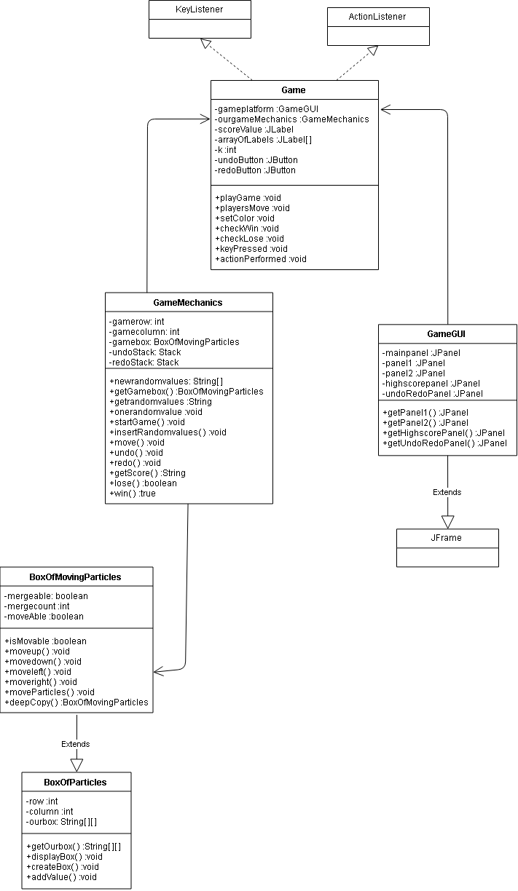
- Features:
Undo, Redo features (achieved by using Stack)
- Git:
https://github.com/nguyenanhdung1206/2048-game

